Collections and Generics Homework
Linda LaMee
- The ArrayList keeps duplicate entries and keeps the items in the order that they were entered into the list. I asked Java if there were ways of manipulating the individual data by indexes and it told me how they can set items in the list and insert items in the list in addition to the methods already shown.
  - set(index, value)
  - add (index, value)
- The HashSet does not store any duplicates so if you add something that is already there, an additional item does not get added. However, the program does not crash or throw an exception when you do try to send a duplicate. It does not seem to send a warning either though. According to ChatGPT the add method does returns a true value if the item was added and a false if it did not.
- When Maya’s score is entered twice, the second time overrites the first one in HashMap. According to ChatGPT, the put command returns the previous score when replacing a previous the value for an existing key.
- In the ArrayDeque class peek looks at the data, poll actually retrieves and aremoves the first element in the queqe.
- In Generics the T represents any object type. We use Integer instead of int because the method is written so that only reference data types can be processed, not primitive data types. Integer is the wrapper class for int.
- The Generics example displayed the joy in generics so that you don’t have to duplicate a lot of code.
Screenshot of Collection
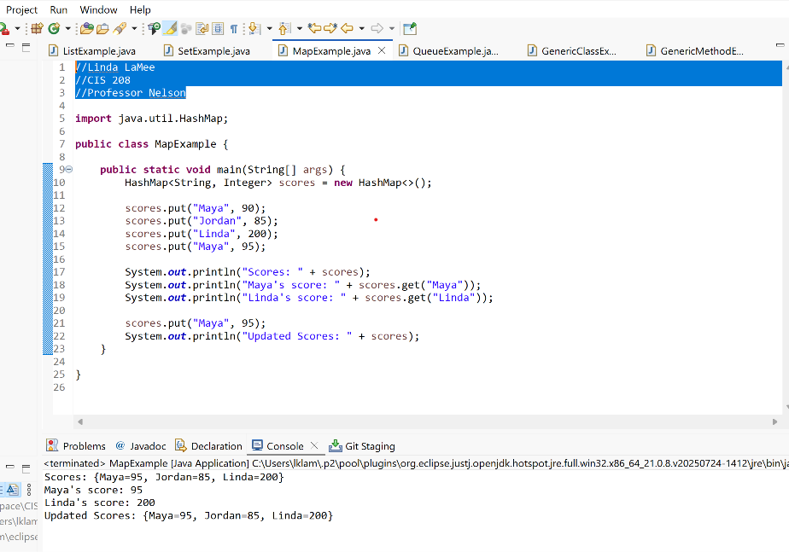
Screenshot of Generics


